Decorator
(Structural)

The Decorator design pattern is a structural pattern used in object-oriented programming to add new functionality to objects dynamically without altering their structure. In Java, this pattern is often employed to extend the behavior of objects in a flexible and reusable way.
The Decorator Pattern is commonly used in scenarios where a variety of optional features or behaviors need to be added to objects in a flexible and reusable manner, such as in text formatting, graphical user interfaces, or customization of products like coffee or ice cream.
Example of Decorator Method Design Pattern
Imagine a pizza shop where customers can customize their pizzas with various toppings like cheese, pepperoni, mushrooms, and olives. The goal is to create a flexible system that allows you to dynamically add any combination of toppings to a base pizza without modifying the existing pizza classes or creating numerous subclasses.
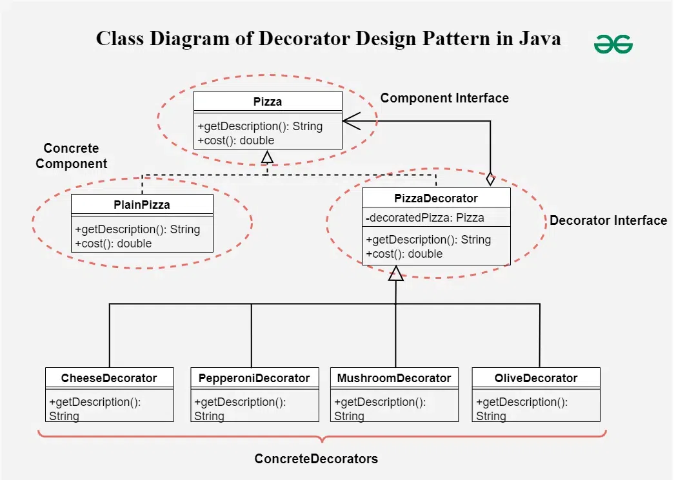

1. Component Interface
public interface Pizza {
String getDescription();
double cost();
}

2. Concrete Component
public class PlainPizza implements Pizza {
@Override
public String getDescription() {
return "Plain pizza";
}

@Override
public double cost() {
return 8.0; // Base price of the pizza
}
}

3. Abstract Decorator
public abstract class PizzaDecorator implements Pizza {
protected Pizza decoratedPizza;

public PizzaDecorator(Pizza decoratedPizza) {
this.decoratedPizza = decoratedPizza;
}

@Override
public String getDescription() {
return decoratedPizza.getDescription();
}

@Override
public double cost() {
return decoratedPizza.cost();
}
}

4. Concrete Decorators
public class CheeseDecorator extends PizzaDecorator {
public CheeseDecorator(Pizza decoratedPizza) {
super(decoratedPizza);
}

@Override
public String getDescription() {
return decoratedPizza.getDescription() + ", cheese";
}

@Override
public double cost() {
return decoratedPizza.cost() + 1.5; // Cost of cheese topping
}
}

public class PepperoniDecorator extends PizzaDecorator {
public PepperoniDecorator(Pizza decoratedPizza) {
super(decoratedPizza);
}

@Override
public String getDescription() {
return decoratedPizza.getDescription() + ", pepperoni";
}

@Override
public double cost() {
return decoratedPizza.cost() + 2.0; // Cost of pepperoni topping
}
}

public class MushroomDecorator extends PizzaDecorator {
public MushroomDecorator(Pizza decoratedPizza) {
super(decoratedPizza);
}

@Override
public String getDescription() {
return decoratedPizza.getDescription() + ", mushrooms";
}

@Override
public double cost() {
return decoratedPizza.cost() + 1.0; // Cost of mushroom topping
}
}

public class OliveDecorator extends PizzaDecorator {
public OliveDecorator(Pizza decoratedPizza) {
super(decoratedPizza);
}

@Override
public String getDescription() {
return decoratedPizza.getDescription() + ", olives";
}

@Override
public double cost() {
return decoratedPizza.cost() + 0.75; // Cost of olive topping
}
}

Demo
public class PizzaShop {
public static void main(String[] args) {
Pizza pizza = new PlainPizza();
System.out.println(pizza.getDescription() + " $" + pizza.cost());

pizza = new CheeseDecorator(pizza);
System.out.println(pizza.getDescription() + " $" + pizza.cost());

pizza = new PepperoniDecorator(pizza);
System.out.println(pizza.getDescription() + " $" + pizza.cost());

pizza = new MushroomDecorator(pizza);
System.out.println(pizza.getDescription() + " $" + pizza.cost());

pizza = new OliveDecorator(pizza);
System.out.println(pizza.getDescription() + " $" + pizza.cost());
}
}

Output:
Plain pizza $8.0
Plain pizza, cheese $9.5
Plain pizza, cheese, pepperoni $11.5
Plain pizza, cheese, pepperoni, mushrooms $12.5
Plain pizza, cheese, pepperoni, mushrooms, olives $13.25
Resources:
https://www.geeksforgeeks.org/decorator-design-pattern-in-java-with-example/

